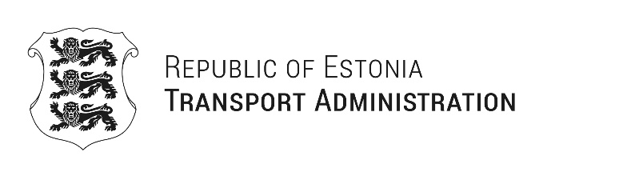
Paweł Woźniak  Director General  General Directorate for National Roads and Motorways  Republic of Poland  kontakt@gddkia.gov.pl | Your ref 07.01.2026 no DSS.ZWM.0722.2.2025.KJP  Our ref 19.01.2026 nr 1.8-3/26/283-2

Acceptance of Invitation to the Meeting in Warsaw 28.08.2026
Dear Director General,

Thank you very much for your kind letter and for the invitation to participate the meeting of road administrations to be held on Friday, 28 August 2026, at the headquarters of GDDKiA in Warsaw. I highly appreciate your initiative to strengthen cooperation between the road administrations of Latvia, Estonia, Lithuania and Poland.

I am pleased to confirm that the Estonian Road Administration will participate in the meeting. I expect to attend the meeting personally, accompanied by the Director of the Strategic Planning Division and the Director of the Road Management Division. We believe that this meeting will provide a valuable platform for deepening professional dialogue, sharing best practices and identifying opportunities for further cooperation among our administrations.

We would be happy to contribute to the preparation of the agenda and suggest topics of mutual interest. Our colleagues will remain in close contact with your team to coordinate the programme and practical arrangements.

Thank you once again for the invitation. I look forward to meeting you in Warsaw and to a fruitful and constructive discussion.
Yours sincerely
Priit Sauk
Director General

Copy to: Latvian State Roads; Lithuanian Road Administration
Stella Timmer
+372 5568 2327, Stella.Timmer@transpordiamet.ee

